Leaders Guide &
Definitions
Emergency Preparedness Leader’s Guide

Developing an Emergency Preparedness Plan is a team approach. The facility emergency preparedness plan, which is based upon an all-hazards approach community based risk assessment and also includes routine safety and physical plant safety risk mitigation processes.

Risk Assessment is general terminology that is within the emergency preparedness regulations and preamble to the Final Rule which describes a process facilities are to use to assess and document potential hazards within their areas and the vulnerabilities and challenges which may impact the facility.

Hazard Vulnerability Assessments (HVAs) which provide an all-hazards approach to assess risk, are systematic approaches to identifying hazards or risks that are most likely to have an impact on a healthcare facility and the surrounding community. The HVA describes the process by which a provider or supplier will assess and identify potential gaps in its emergency plan(s).
Potential loss scenarios should be identified first during the risk assessment. Once a risk assessment has been conducted and a facility has identified the potential hazards/risks they may face, the organization can use those hazards/risks to conduct a Business Impact Analysis.

The Emergency Preparedness Plan should be compatible and integrated with the facility assessment and the facility infection prevention program. As one is updated, so should the others.

Emergency Preparedness Requirements
§ 483.73 Emergency preparedness. A facility must comply with all applicable Federal, State, and local emergency preparedness requirements. The facility must establish and maintain a comprehensive emergency preparedness program that meets the requirements of this section.

The emergency preparedness program must include, but not be limited to, the following elements:

Emergency Plan – Planning and Risk Assessment - The LTC facility must develop and maintain an emergency preparedness plan that must be reviewed and updated at least annually. The plan must do all of the following:

(1) Be based on and include a documented, facility‐based and community‐based risk assessment, utilizing an all‐hazards approach, including missing residents.
(2) Include strategies for addressing emergency events identified by the risk assessment.
(3) Address resident population, including, but not limited to, persons at‐risk; the type of services the LTC facility has the ability to provide in an emergency; and continuity of operations, including delegations of authority and succession plans.
(4) Include a process for cooperation and collaboration with local, tribal, regional, State, and Federal emergency preparedness officials' efforts to maintain an integrated response during a disaster or emergency situation.
Policies and Procedures - The facility must develop and implement emergency preparedness policies and procedures, based on the emergency plan set forth in paragraph (a) of this section, risk assessment at paragraph (a)(1) of this section, and the communication plan at paragraph (c) of this section. The policies and procedures must be reviewed and updated at least annually. At a minimum, the policies and procedures must address the following:

- The provision of subsistence needs for staff and residents, whether they evacuate or shelter in place, include, but are not limited to the following:
(i) Food, water, medical, and pharmaceutical supplies.
(ii) Alternate sources of energy to maintain the following:
(A) Temperatures to protect resident health and safety and for the safe and sanitary storage of provisions.
(B) Emergency lighting.
(C) Fire detection, extinguishing, and alarm systems.
(D) Sewage and waste disposal.
(2) A system to track the location of on‐duty staff and sheltered patients in the facility's care during an emergency. If on‐duty staff and sheltered patients are relocated during the emergency, the facility must document the specific name and location of the receiving facility or other location.
(3) Safe evacuation from the facility, which includes consideration of care and treatment needs of evacuees; staff responsibilities; transportation; identification of evacuation location(s); and primary and alternate means of communication with external sources of assistance.
(4) A means to shelter in place for patients, staff, and volunteers who remain in the facility.
(5) A system of medical documentation that preserves patient information, protects confidentiality of patient information, and secures and maintains the availability of records.
(6) The use of volunteers in an emergency or other emergency staffing strategies, including the process and role for integration of State or Federally designated health care professionals to address surge needs during an emergency.
(7) The development of arrangements with other facilities and other providers to receive patients in the event of limitations or cessation of operations to maintain the continuity of services to facility patients.
(8) The role of the facility under a waiver declared by the Secretary, in accordance with section 1135 of the Act, in the provision of care and treatment at an alternate care site identified by emergency management officials.

Communication Plan - The facility must develop and maintain an emergency preparedness communication plan that complies with Federal, State, and local laws and must be reviewed and updated at least annually. The communication plan must include all of the following:

- Names and contact information for the following:
  - Staff.
  - Entities providing services under arrangement.
  - Patients' physicians.
  - Other facilities.
  - Volunteers.

(2) Contact information for the following:
- Federal, State, tribal, regional, and local emergency preparedness staff.
- The State Licensing and Certification Agency.
- The Office of the State Long-Term Care Ombudsman.
- Other sources of assistance.

(3) Primary and alternate means for communicating with the following:
- Facility staff.
- Federal, State, tribal, regional, and local emergency management agencies.

(4) A method for sharing information and medical documentation for patients under the facility's care, as necessary, with other health care providers to maintain the continuity of care.

(5) A means, in the event of an evacuation, to release patient information as permitted per requirements.

(6) A means of providing information about the general condition and location of patients under the facility's care as permitted requirements.

(7) A means of providing information about the facility's occupancy, needs, and its ability to provide assistance, to the authority having jurisdiction, the Incident Command Center, or designee.

(8) A method for sharing information from the emergency plan, that the facility has determined is appropriate, with residents and their families or representatives.

Training and Testing - The LTC facility must develop and maintain an emergency preparedness training and testing program that is based on the emergency plan set forth in paragraph (a) of this section, risk assessment at paragraph (a)(1) of this section, policies and procedures at paragraph (b) of this section, and the communication plan at paragraph (c) of this section. The training and testing program must be reviewed and updated at least annually.
- Training program. The LTC facility must do the following:
  - Initial training in emergency preparedness policies and procedures to all new and existing staff, individuals providing services under arrangement, and volunteers, consistent with their expected roles.
  - Provide emergency preparedness training at least annually.
  - Maintain documentation of all emergency preparedness training.
  - Demonstrate staff knowledge of emergency procedures.

- Testing. The facility must conduct exercises to test the emergency plan at least twice per year, including unannounced staff drills using the emergency procedures. **For providers of inpatient services, i9nludinc LTC facilities: The testing exercises were expanded to include workshops as an exercise of choice. However, providers are still required to conduct two emergency preparedness testing exercises annually.
  - Definitions Testing Exercises
    - CMS defines the testing exercises required under the emergency preparedness regulations in two categories. Specifically, 1) full-scale, functional, and individual-facility-based exercises as the "required" exercises; and 2) mock disaster drills, table-top exercises, or workshops as the "exercises of choice," which could also include the full-scale functional and individual-facility based exercises. CMS further defines the exercises as follows:
      - Full-Scale Exercise (FSE): A full scale exercise is an operations-based exercise that typically involves multiple agencies, jurisdictions, and disciplines performing functional (for example, joint field office, emergency operation centers, etc.) and integration of operational elements involved in the response to a disaster event, i.e. "boots on the ground" response activities (for example, hospital staff treating mock patients).
      - Functional Exercise (FE): "FEs are designed to validate and evaluate capabilities, multiple functions and/or sub-functions, or interdependent groups of functions. FEs are typically focused on exercising plans, policies, procedures, and staff members involved in management, direction, command, and control functions" as defined by DHS's Homeland Security Exercise and Evaluation Program (HSEEP).
      - Mock Disaster Drill (Exercise of Choice Only): A drill is a coordinated, supervised activity usually employed to validate a specific function or capability in a single agency or organization. Drills are commonly used to provide training on new equipment, validate procedures, or practice and maintain current skills. For example, drills may be appropriate for establishing a community-designated disaster-receiving center or shelter. Drills can also be used to determine if plans can be executed as designed, to assess whether more training is required, or to reinforce best practices. A drill is useful as a stand-alone tool, but a series of drills can be used to prepare several organizations to collaborate in an FSE.
      - Table-top Exercise (TTX) (Exercise of Choice Only): A table-top exercise involves key personnel discussing simulated scenarios in an informal setting. TTXs can be used to assess plans, policies, and procedures. A table-top exercise is a discussion-based exercise that involves senior staff, elected or appointed officials, and other key decision making personnel in a group discussion centered on a hypothetical scenario. TTXs can be used to assess plans, policies, and procedures without deploying resources.
      - Workshop (Exercise of Choice Only): A workshop, for the purposes of this guidance, is a planning meeting/workshop, which establishes the strategy and structure for an exercise program as defined in HSEEP guidelines.
- The facility must do the following:
- Participate in an annual full-scale exercise that is community-based; or
- When a community-based exercise is not accessible, conduct an annual individual, facility-based functional exercise.
- If the LTC facility experiences an actual natural or man-made emergency that requires activation of the emergency plan, the LTC facility is exempt from engaging in a community-based or individual, facility-based full-scale exercise for 1 year following the onset of the actual event.
- Conduct an additional annual exercise that may include, but is not limited to the following:
  - A second full-scale exercise that is community-based or an individual, facility-based functional exercise; or
  - A mock disaster drill; or
  - A tabletop exercise or workshop that is led by a facilitator, includes a group discussion, using a narrated, clinically-relevant emergency scenario, and a set of problem statements, directed messages, or prepared questions designed to challenge an emergency plan.
- Analyze the facility's response to and maintain documentation of all drills, tabletop exercises, and emergency events, and revise the` facility's emergency plan, as needed.
- Exemption Based on Actual Natural or Man-made Emergency
  - The emergency preparedness regulations allow an exemption for providers or suppliers that experience a natural or man-made event requiring activation of their emergency plan. For example, on Friday, March 13, 2020, the President declared a national emergency due to COVID-19 and subsequently many providers and suppliers have activated their emergency plans in order to address surge and coordinate response activities.
    - Facilities that activate their emergency plans are exempt from the next required full-scale community-based or individual, facility-based functional exercise.
    - Facilities must be able to demonstrate, through written documentation, that they activated their program due to the emergency.
    - CMS requires facilities to conduct an exercise of choice annually for inpatient providers. Providers are still required to conduct two emergency preparedness testing exercises annually. (In May 2022, testing exercises were expanded to include workshops as an exercise of choice.
      - For the "exercise of choice," facilities must conduct one of the testing exercises below:
        - Another full-scale exercise;
        - Individual-facility-based functional exercise;
        - Mock disaster drill; or
        - A table-top exercise or workshop. Facilities may choose to conduct a table-top exercise (TTX) which could assess the facility's response to COVID-19. This may include but is not limited to, discussions surrounding availability of personal protective equipment (PPE); isolation and quarantine areas for screening patients; or any other activities implemented during the activation of the emergency plan.
    - The emergency preparedness provisions require that facilities assess and update their emergency program as needed. Therefore, lessons learned, and challenges identified in the TTX may allow a facility to adjust its plans accordingly.
    - Public Health Emergency Exemptions (See updated CMS Guidance during a PHE) - CMS recognizes many facilities are still operating under disaster/emergency conditions during the PHE, i.e., under an activated emergency plan. See the updated guidance related to exemptions due to PHE or declared emergencies in alignment with the guidance. https://www.cms.gov/files/document/qso-20-41-all-revised-05262022.pdf

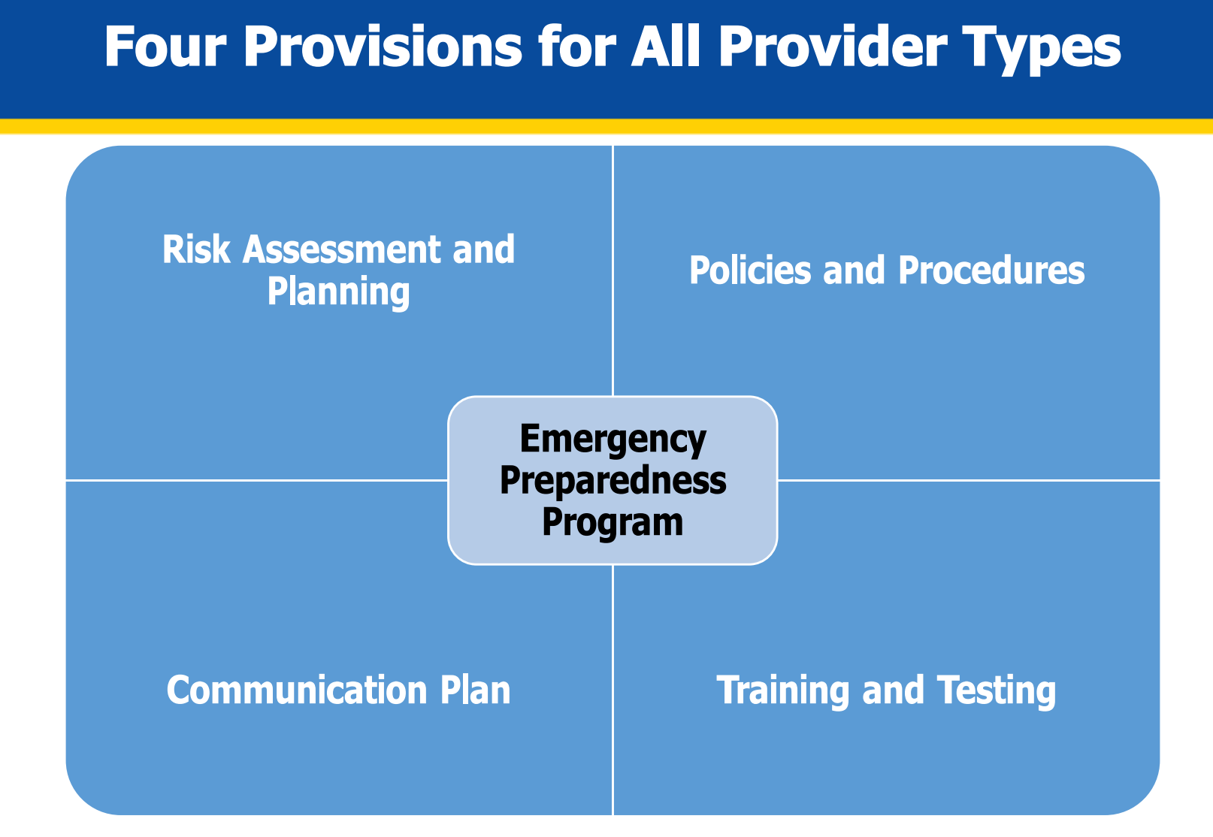
Source: https://qsep.cms.gov/data/104/FINAL8-14-EP-NatlWebinar-SURVEYOR-READINES.PDF

Emergency and standby power systems – The facility must implement emergency and standby power systems based on the emergency plan set forth in paragraph (a) of the section.

- Emergency generator location – The generator must be located in accordance with the location requirements

- Emergency generator inspection and testing - The facility must implement the emergency power system inspection, testing, and maintenance requirements found in the Health Care Facilities Code, NFPA 110, and Life Safety Code.

- Emergency generator fuel - Facilities that maintain an onsite fuel source to power emergency generators must have a plan for how it will keep emergency power systems operational during the emergency unless it evacuates.

Definitions Relative to the Emergency Preparedness Requirements

- All-Hazards Approach: An all-hazards approach is an integrated approach to emergency preparedness that focuses on identifying hazards and developing emergency preparedness capacities and capabilities that can address those as well as a wide spectrum of emergencies or disasters. This approach includes preparedness for natural, man-made, and or facility emergencies that may include but is not limited to care-related emergencies; equipment and power failures; interruptions in communications, including cyber-attacks; loss of a portion or all of a facility; and interruptions in the normal supply of essentials, such as water and food. Planning for using an all-hazards approach should also include emerging infectious disease (EID) threats. Examples of EIDs include Influenza, Ebola, Zika Virus, and others. All facilities must develop an all-hazards emergency preparedness program and plan.

- Community Partners: Community partners are considered any emergency management officials (fire, police, emergency medical services, etc.) for full-scale and community-based exercises, however can also include community partners that assist in an emergency, such as surrounding providers and suppliers.

- Disaster: A hazard impact causing adverse physical, social, psychological, economic, or political effects that challenges the ability to respond rapidly and effectively. Despite a stepped-up capacity and capability (call-back procedures, mutual aid, etc.) and change from routine management methods to an incident command/management process, the outcome is lower than expected compared with a smaller scale or lower magnitude impact (see “emergency” for important contrast between the two terms). Reference: Assistant Secretary for Preparedness and Response (ASPR) 2017-2022 Health Care Preparedness and Response Capabilities Document (ICDRM/GWU Emergency Management Glossary of Terms) (November 2016).

- Emergency/Disaster: An event that can affect the facility internally as well as the overall target population or the community at large or community or a geographic area.

- Emergency: A hazard impact causing adverse physical, social, psychological, economic or political effects that challenges the ability to respond rapidly and effectively. It requires a stepped-up capacity and capability (call-back procedures, mutual aid, etc.) to meet the expected outcome, and commonly requires change from routine management methods to an incident command process to achieve the expected outcome (see “disaster” for important contrast between the two terms). Reference: Assistant Secretary for Preparedness and Response (ASPR) 2017-2022 Health Care Preparedness and Response Capabilities Document (ICDRM/GWU Emergency Management Glossary of Terms) (November 2016).

- Emergency Preparedness Program: The Emergency Preparedness Program describes a facility’s comprehensive approach to meeting the health, safety and security needs of the facility, its staff, their patient population, and community prior to, during and after an emergency or disaster. The program encompasses four core elements: Emergency Plan that is based on a Risk Assessment and incorporates an all-hazards approach; Policies and Procedures; Communication Plan; and the Training and Testing Program.

- Emergency Plan: An emergency plan provides the framework for the emergency preparedness program. The emergency plan is developed based on facility- and community-based risk assessments that assist a facility in anticipating and addressing facility, patient, staff, and community needs and support continuity of business operations.

- Facility-Based: We consider the term “facility-based” to mean the emergency preparedness program is specific to the facility. It includes but is not limited to hazards specific to a facility based on its geographic location; dependent patient/resident/client and community population; facility type and potential surrounding community assets- i.e., rural area versus a large metropolitan area.

- Risk Assessment: The term risk assessment describes a process facilities use to assess and document potential hazards that are likely to impact their geographical region, community, facility, and patient population and identify gaps and challenges that should be considered and addressed in developing the emergency preparedness program. The term risk assessment is meant to be comprehensive, and may include a variety of methods to assess and document potential hazards and their impacts. The healthcare industry has also referred to risk assessments as a Hazard Vulnerability Assessments or Analysis (HVA) as a type of risk assessment commonly used in the healthcare industry.

- Staff: The term "staff" refers to all individuals that are employed directly by a facility. The phrase "individuals providing services under arrangement" means services furnished under arrangement that are subject to a written contract conforming with the requirements specified in section 1861(w) of the Act.

- Testing Exercise Definitions: CMS defines the testing exercises required under the emergency preparedness regulations in two categories. Specifically, 1) full-scale, functional, and individual-facility-based exercises as the "required" exercises; and 2) mock disaster drills, table-top exercises, or workshops as the "exercises of choice," which could also include the full-scale functional and individual-facility based exercises. CMS further defines the exercises as follows:

  - Full-Scale Exercise (FSE): A full scale exercise is an operations-based exercise that typically involves multiple agencies, jurisdictions, and disciplines performing functional (for example, joint field office, emergency operation centers, etc.) and integration of operational elements involved in the response to a disaster event, i.e. "boots on the ground" response activities (for example, hospital staff treating mock patients).
  - Functional Exercise (FE): "FEs are designed to validate and evaluate capabilities, multiple functions and/or sub-functions, or interdependent groups of functions. FEs are typically focused on exercising plans, policies, procedures, and staff members involved in management, direction, command, and control functions" as defined by DHS's Homeland Security Exercise and Evaluation Program (HSEEP).
  - Mock Disaster Drill (Exercise of Choice Only): A drill is a coordinated, supervised activity usually employed to validate a specific function or capability in a single agency or organization. Drills are commonly used to provide training on new equipment, validate procedures, or practice and maintain current skills. For example, drills may be appropriate for establishing a community- designated disaster-receiving center or shelter. Drills can also be used to determine if plans can be executed as designed, to assess whether more training is required, or to reinforce best practices. A drill is useful as a stand-alone tool, but a series of drills can be used to prepare several organizations to collaborate in an FSE.
  - Table-top Exercise (TTX) (Exercise of Choice Only): A table-top exercise involves key personnel discussing simulated scenarios in an informal setting. TTXs can be used to assess plans, policies, and procedures. A table-top exercise is a discussion-based exercise that involves senior staff, elected or appointed officials, and other key decision making personnel in a group discussion centered on a hypothetical scenario. TTXs can be used to assess plans, policies, and procedures without deploying resources.
  - Workshop (Exercise of Choice Only): A workshop, for the purposes of this guidance, is a planning meeting/workshop, which establishes the strategy and structure for an exercise program as defined in HSEEP guidelines.
    - https://preptoolkit.fema.gov/documents/1269813/1269861/HSEEP_Revision_Apr13_Fina l.pdf/65bc7843-1d10-47b7-bc0d-45118a4d21da

Resources and References:

The Centers for Medicare and Medicaid Services Emergency Preparedness Rule Resource Site: https://www.cms.gov/Medicare/Provider-Enrollment-and-Certification/SurveyCertEmergPrep/Emergency-Prep-Rule

Updated Guidance for Emergency Preparedness-Appendix Z of the State Operations Manual (SOM) Ref: QSO-21-15-ALL https://www.cms.gov/files/document/qso-20-41-all-revised-05262022.pdf

Revisions to the State Operations Manual (SOM) Appendix Z – Emergency Preparedness Transmittal: 204 issued April 16, 2021 https://www.cms.gov/files/document/r204soma.pdf

The Centers for Medicare and Medicaid Services. Health Care Coalitions. https://www.cms.gov/About-CMS/Agency-Information/Emergency/EPRO/Resources/State-resources

Centers for Medicare & Medicaid Services State Operations Manual, Appendix PP – Guidance to Surveyors for Long Term Care Facilities (Rev. 173, 11-22-17) Advance Copy, 2022: https://www.cms.gov/files/document/appendix-pp-guidance-surveyor-long-term-care-facilities.pdf

